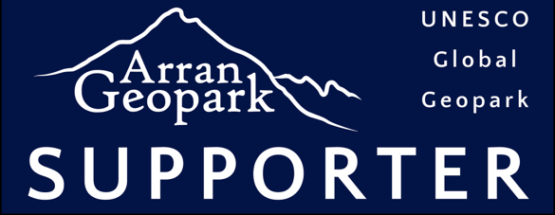**Why should I become a Geopark Supporter?**

Becoming a Geopark Supporter is an opportunity to show your backing for the Geopark and our UNESCO Global Geopark status – which includes the whole of the Isle of Arran.

By signing up you will make a real difference by ensuring that the Geopark is seen and understood. Importantly, you will help to demonstrate that the wider island community supports our vision. We will provide you with:

1. A Geopark Supporter sticker;
2. A listing on our website;
3. Email updates of Geopark news and events; and
4. Space to display promotional material at our Lochranza information centre.

**Sign up now!**

Supporters of Arran UNESCO Global Geopark (‘UGGp’) must meet, or be working towards, the following criteria:

* **Raise awareness of Arran UGGp –** *I/We will promote Arran UGGp and familiarise key staff with the core objectives of the Geopark. We will display the Geopark Supporter sticker and other Geopark promotional material.*
* **Conserve the island’s natural resources –** *I/We will support and contribute to the protection, enhancement, and restoration of the island including its natural heritage, cultural heritage, and landscape value. We will not sell minerals, fossils, or similar original geological materials.*
* **Promote and use local produce –** *I/We will promote local culture, food, crafts, and arts. We will strive to buy goods and services from local and sustainable sources and in doing so increase the distinctiveness of our business whilst propagating positive environmental and economic impacts.*
* **Develop knowledge and understanding –** *I/We will develop knowledge and increase understanding based on existing sources and new research of those special relationships and qualities (in the natural environment, culture, society, and economy) that make up our island.*
* **Contribute to the well-being of the island –** *I/We will contribute attitudes and actions which develop enjoyment of, and pleasure from, the landscape and natural environment; developing links between individuals and communities and their environment to improve health and wellbeing.*
* **Support the UN Sustainable Development Goals –** *I/We will collaborate with businesses, the wider community, and other organisations to support a healthy economy; while pursuing best practice in social, economic, and environmental sustainability.*

|  |  |  |  |
| --- | --- | --- | --- |
| **I/We agree to meet the above criteria to become a Supporter of Arran Geopark.** | | | |
| Organisation: |  | | |
| Name: |  | Signed: |  |
| Position: |  | Date: |  |
|  |  |  |  |